**Database Lookup (Medium)**

**We have detected malicious activity on broadband radio frequencies 2602 - 2608 MHz in Alexandria City, Virginia. We believe the activity to be performed on a leased license. It's up to you to find the information we need.**

*Note: Another helpful site that may be useful for future challenges: <https://www.radioreference.com/>

*Note: If tracking down a live signal, you can use software defined radios as a mobile way to pick up and hone in on the signal.

1. Go to: <https://wireless2.fcc.gov/UlsApp/UlsSearch/searchLicense.jsp>
   1. Universal Licensing System
2. Click “Geographic” on right-hand side 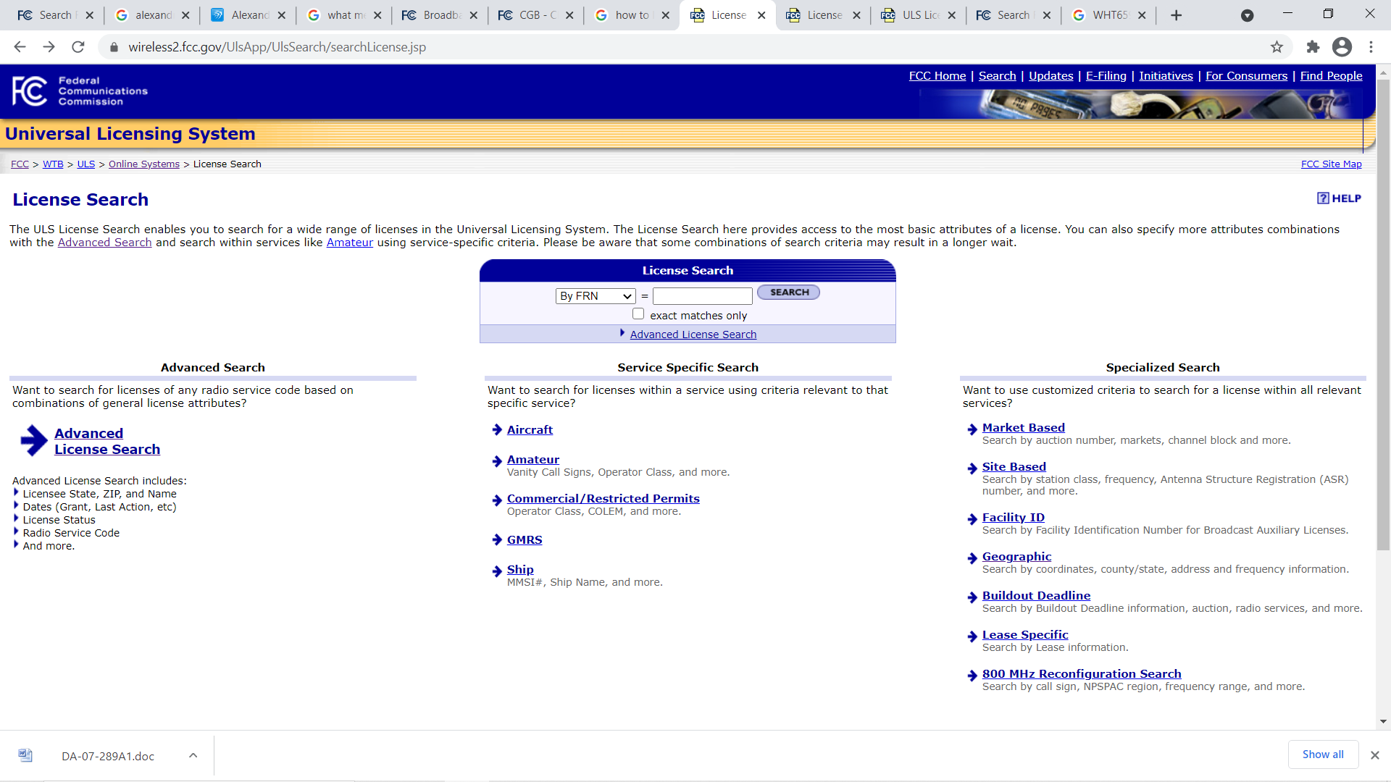
3. Enter in all known info; Virginia = State, Alexandria City = County, 2602 – 2608 = Range

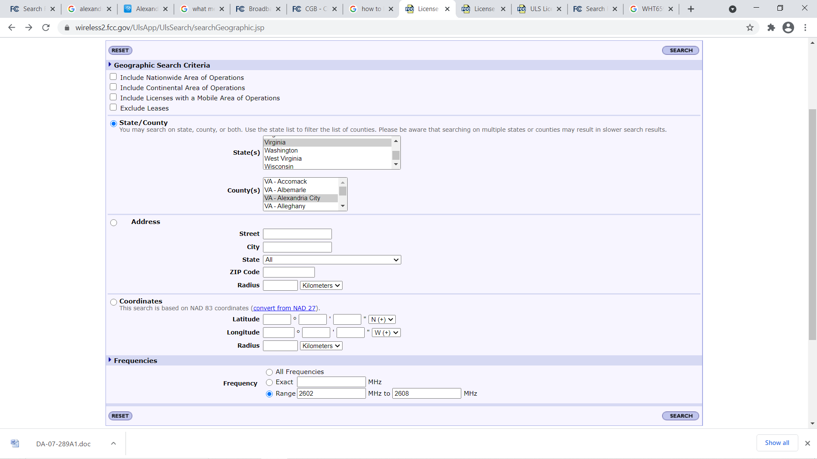

1. Click “F-Corporation” b/c they have a lease symbol (denoted by “L”) next to their name.

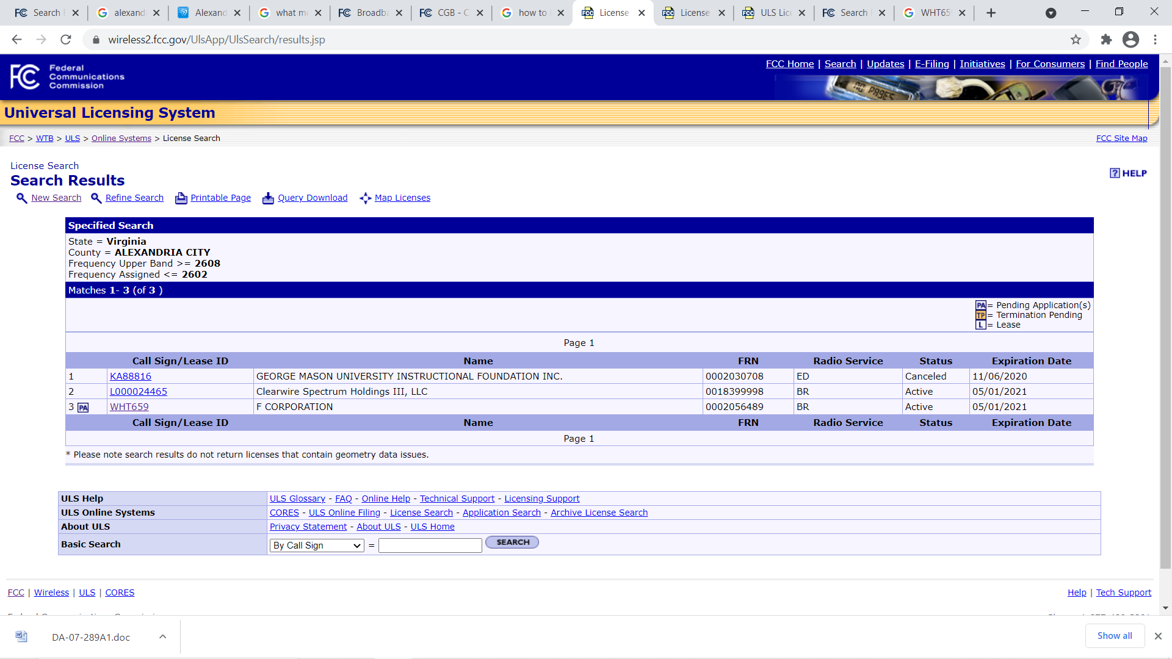

1. From here you can explore the tabs to find answers to all but the last question.

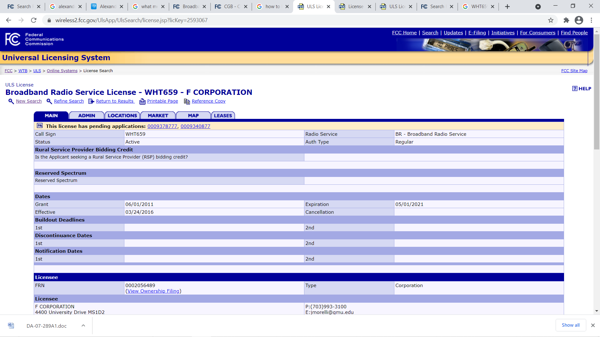

1. Google the call-sign followed by “broadband” to find FCC public notice.
   1. Download the FCC’s Word doc to find official complaint and date filed.

